Hunter Geise

Collaborators: Nolan Pittman, Aidan Myers

1. a. I think the β coefficients for FG%, 3Pt%, DReb, TRB, and STL to be positive. I think the β coefficient for TOV will be negative. Potential imperfect multicollinearity can impact my expectations for FG% and 3Pt%. This is due to 3Pt% being a part of the calculation for FG%. The better 3Pt% a team has, it will skew their FG% and make it more positive, causing a larger coefficient. This is also prevalent in Team DREB and Team TRB where the more DREB a team has, the more TRB they will have which will create a larger coefficient. Also with this, there will be wider confidence intervals due to larger standard errors.

b. 

c. 

d. FG%, TRB, and TOV are problematic since their VIF is all over 5, but less than 10. DREB is heavily impacted by collinearity because its VIF is over 10. STL is impacted by VIF, but it isn’t quite problematic since it is at 4.811.

e. To eliminate multicollinearity from DREB and TRB, I would eliminate the DREB variable and just compare overall rebounding abilities between teams. Keeping TRB is better than keeping DREB because offensive rebounds are a key part to winning games and are kept under consideration when using the TRB variable. Also there is multicollinearity in FG% because it is affected by a team’s 3Pt%. This can be eliminated by getting rid of both 3Pt% and FG% and replacing them with eFG% which still accounts for three pointers a team takes and 2Pt%.

1. a. 

b. Based off of R2 measures, the regression ran in question one is better since more variation in Win% can be explained by the X variables. I think the first model outperformed the second because it used the difference between teams’ percentages and stats which almost doubles as a stat which gives more information on how certain teams performed vs the rest of the league, rather than the second model which is the average among teams.

1. It is important to test for heteroscedasticity to make sure that there are no outliers and that the OLS estimates are BLUE instead of LUE, leading to p-values not being reliable and affecting the decision to reject/fail to reject the null hypothesis. It is important to test for autocorrelation because it can determine whether a model is not efficient, therefore not being BLUE. This can lead to skewing the standard errors and making the hypothesis test not reliable.
2. a. 

b. 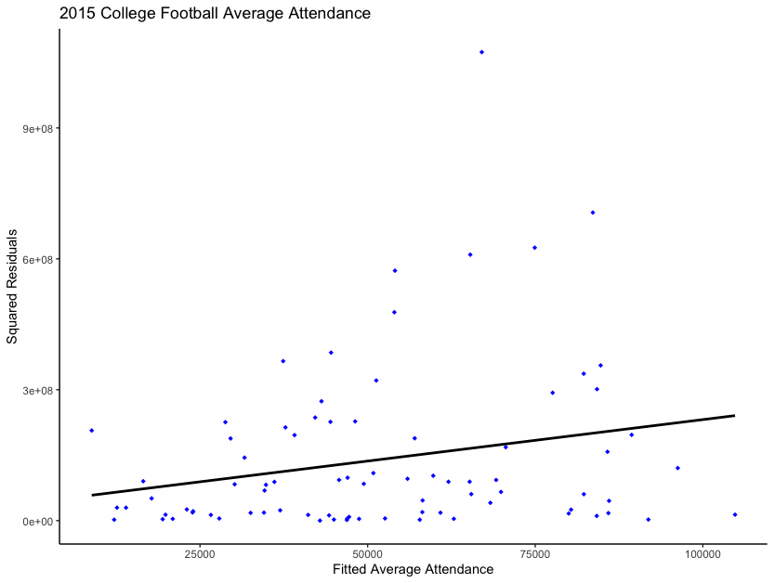 There is heteroscedasticity present because there is more error and variation as values of X increase. This is noticeable where points on the scatter plot venture further away from the line of best fit.

c. 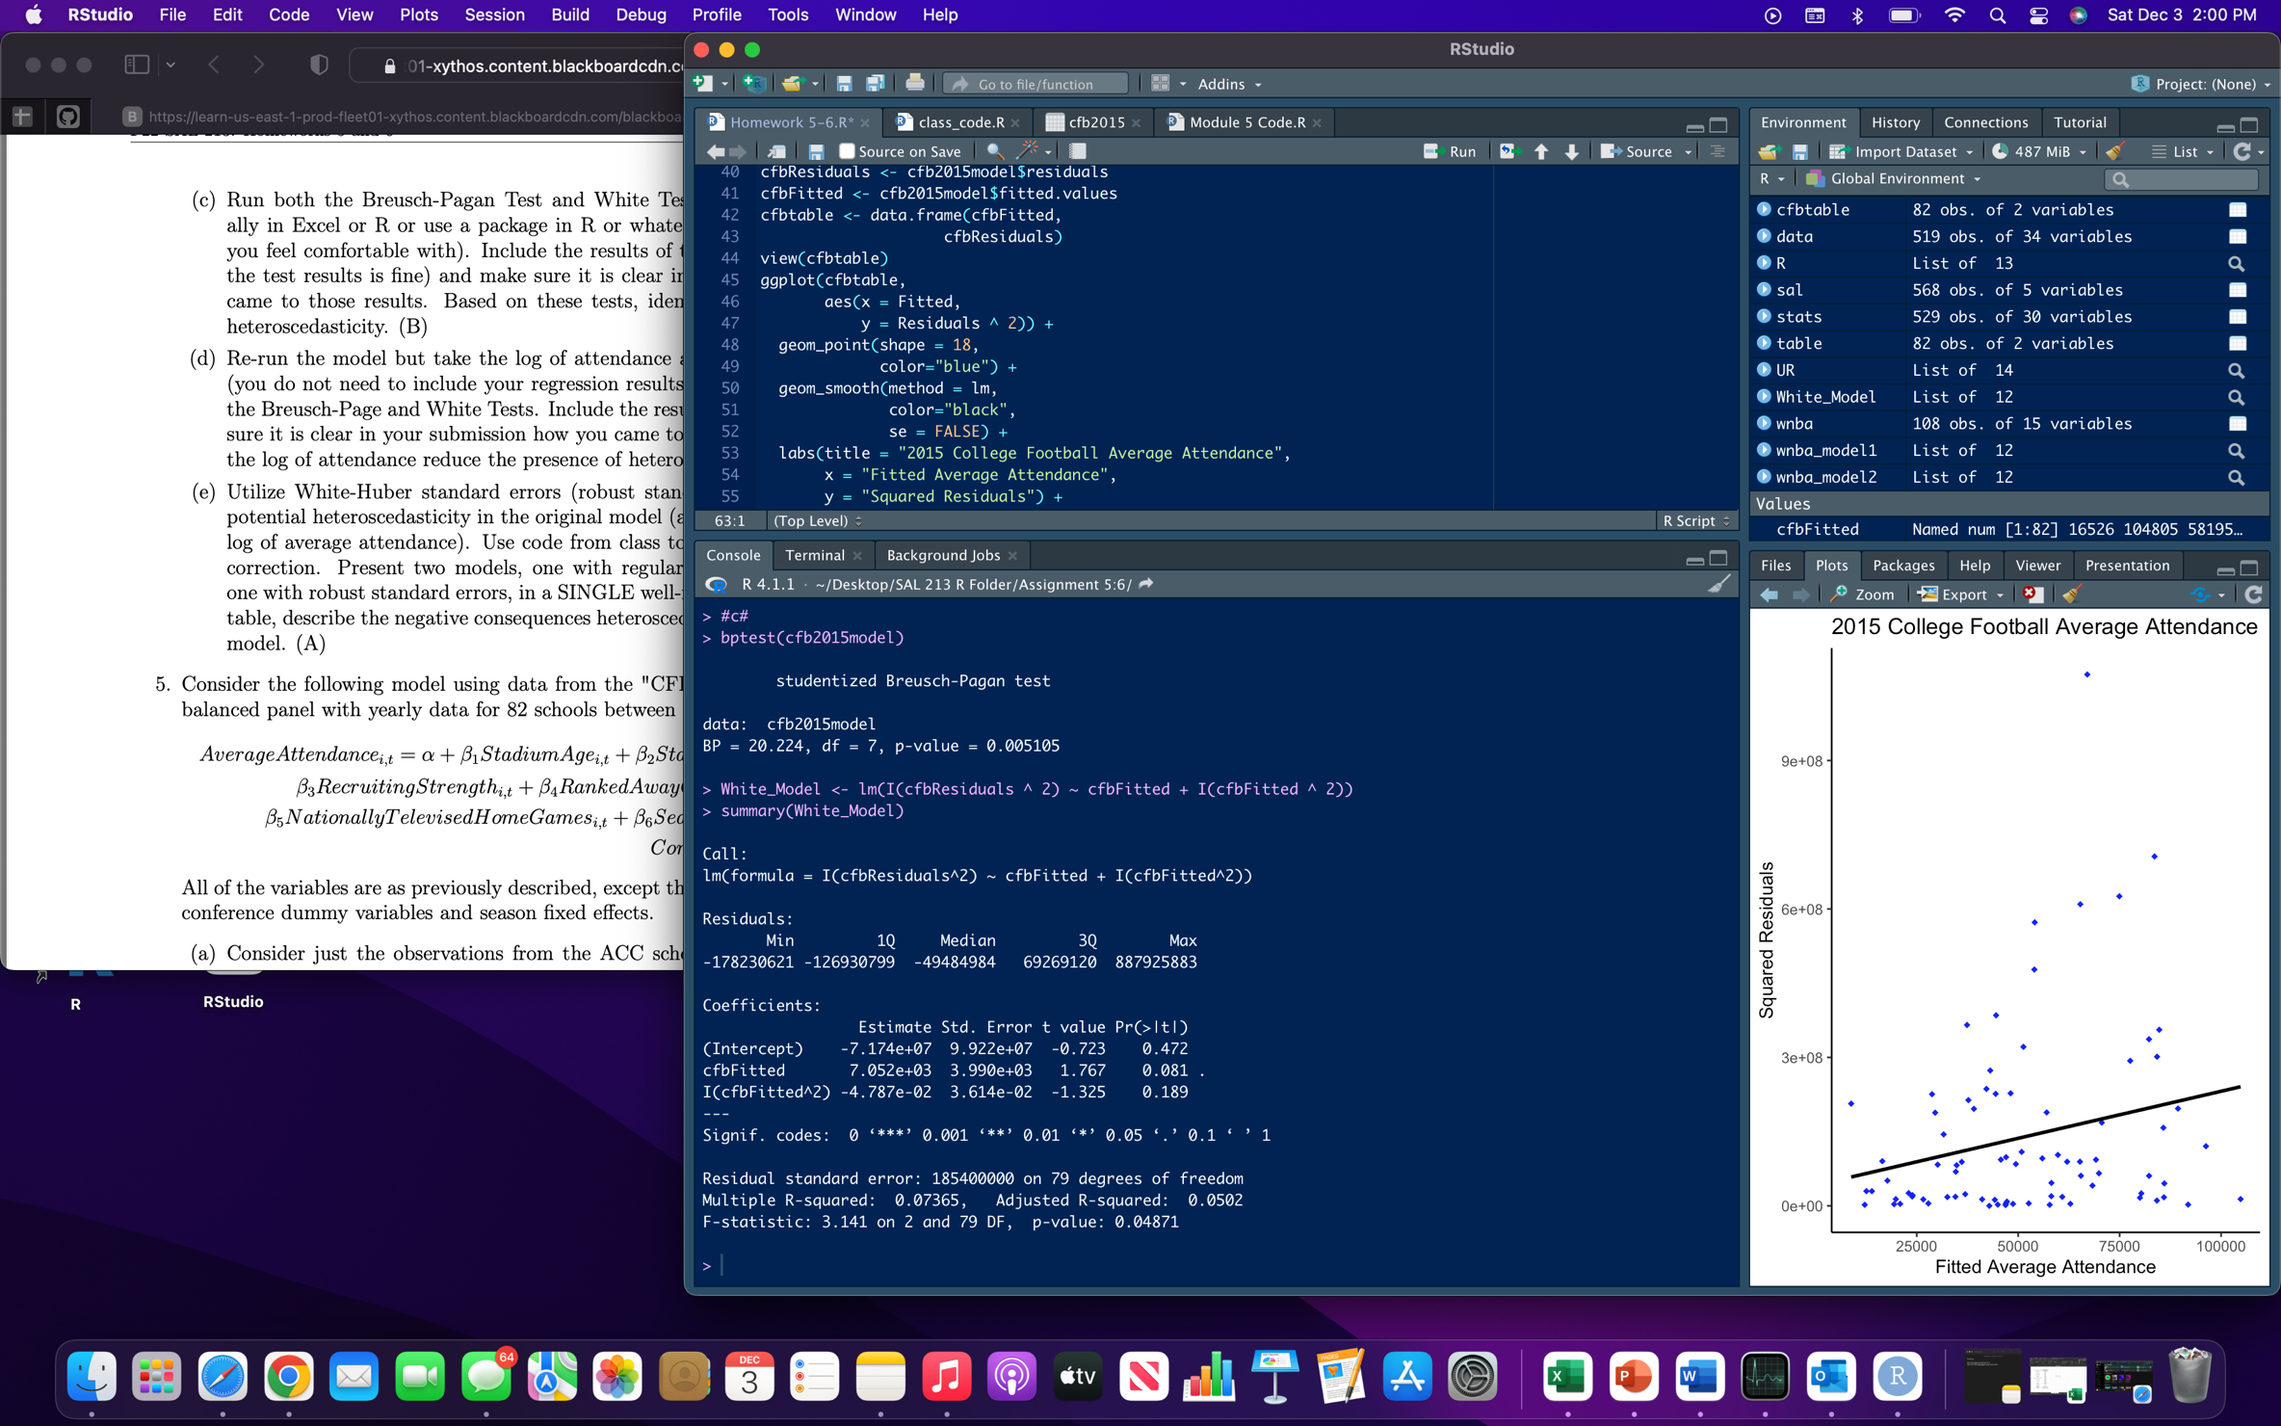 In both tests, the p-values are below the .05 level (BP is 0.005105, White is 0.04871) which gives us enough evidence to reject the null hypothesis of homoscedasticity in favor of the alternative hypothesis of heteroscedasticity.

d. 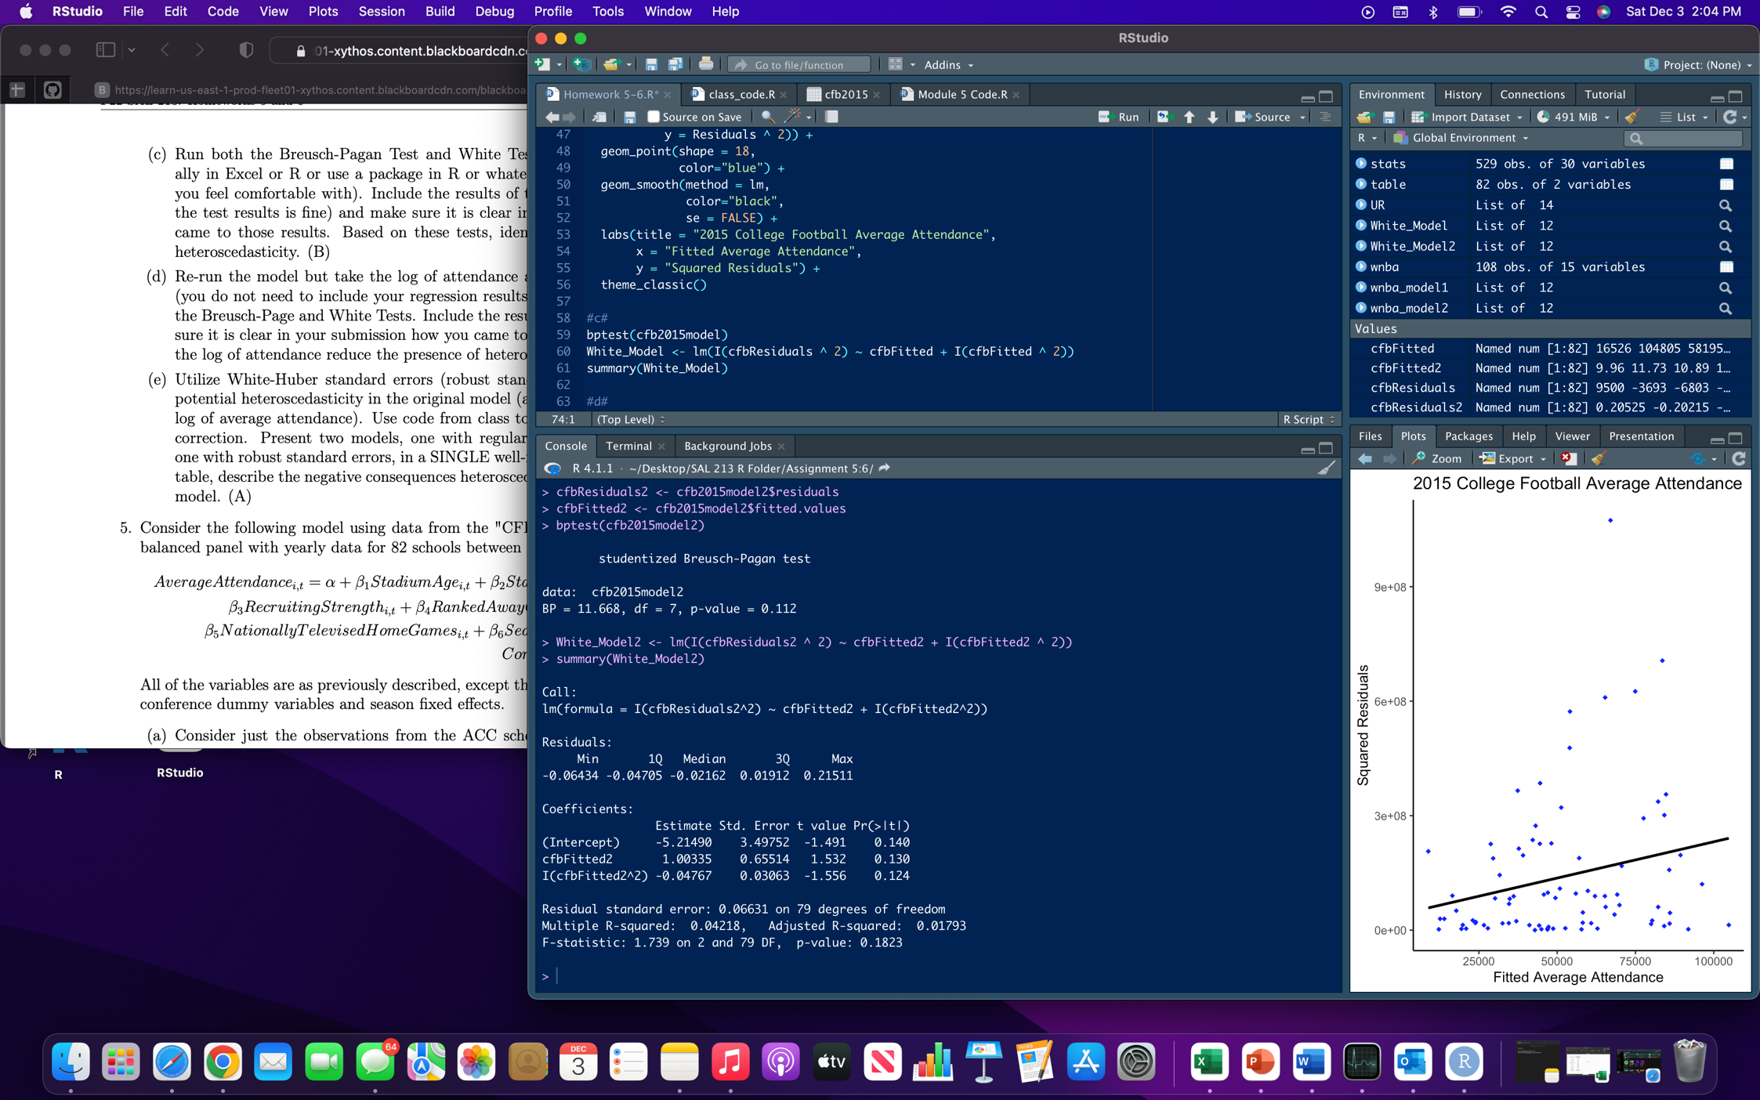 Using the log of attendance does reduce the presence of heteroscedasticity. In both tests, the p-values are above the .05 level (BP is 0.112, White is 0.1823) which does not gives us enough evidence to reject the null hypothesis of homoscedasticity.

e.  Heteroscedasticity gives less correct standard errors which then would affect the confidence interval and p-values of the experiment, making it LUE instead of BLUE.

1. a. 

b. 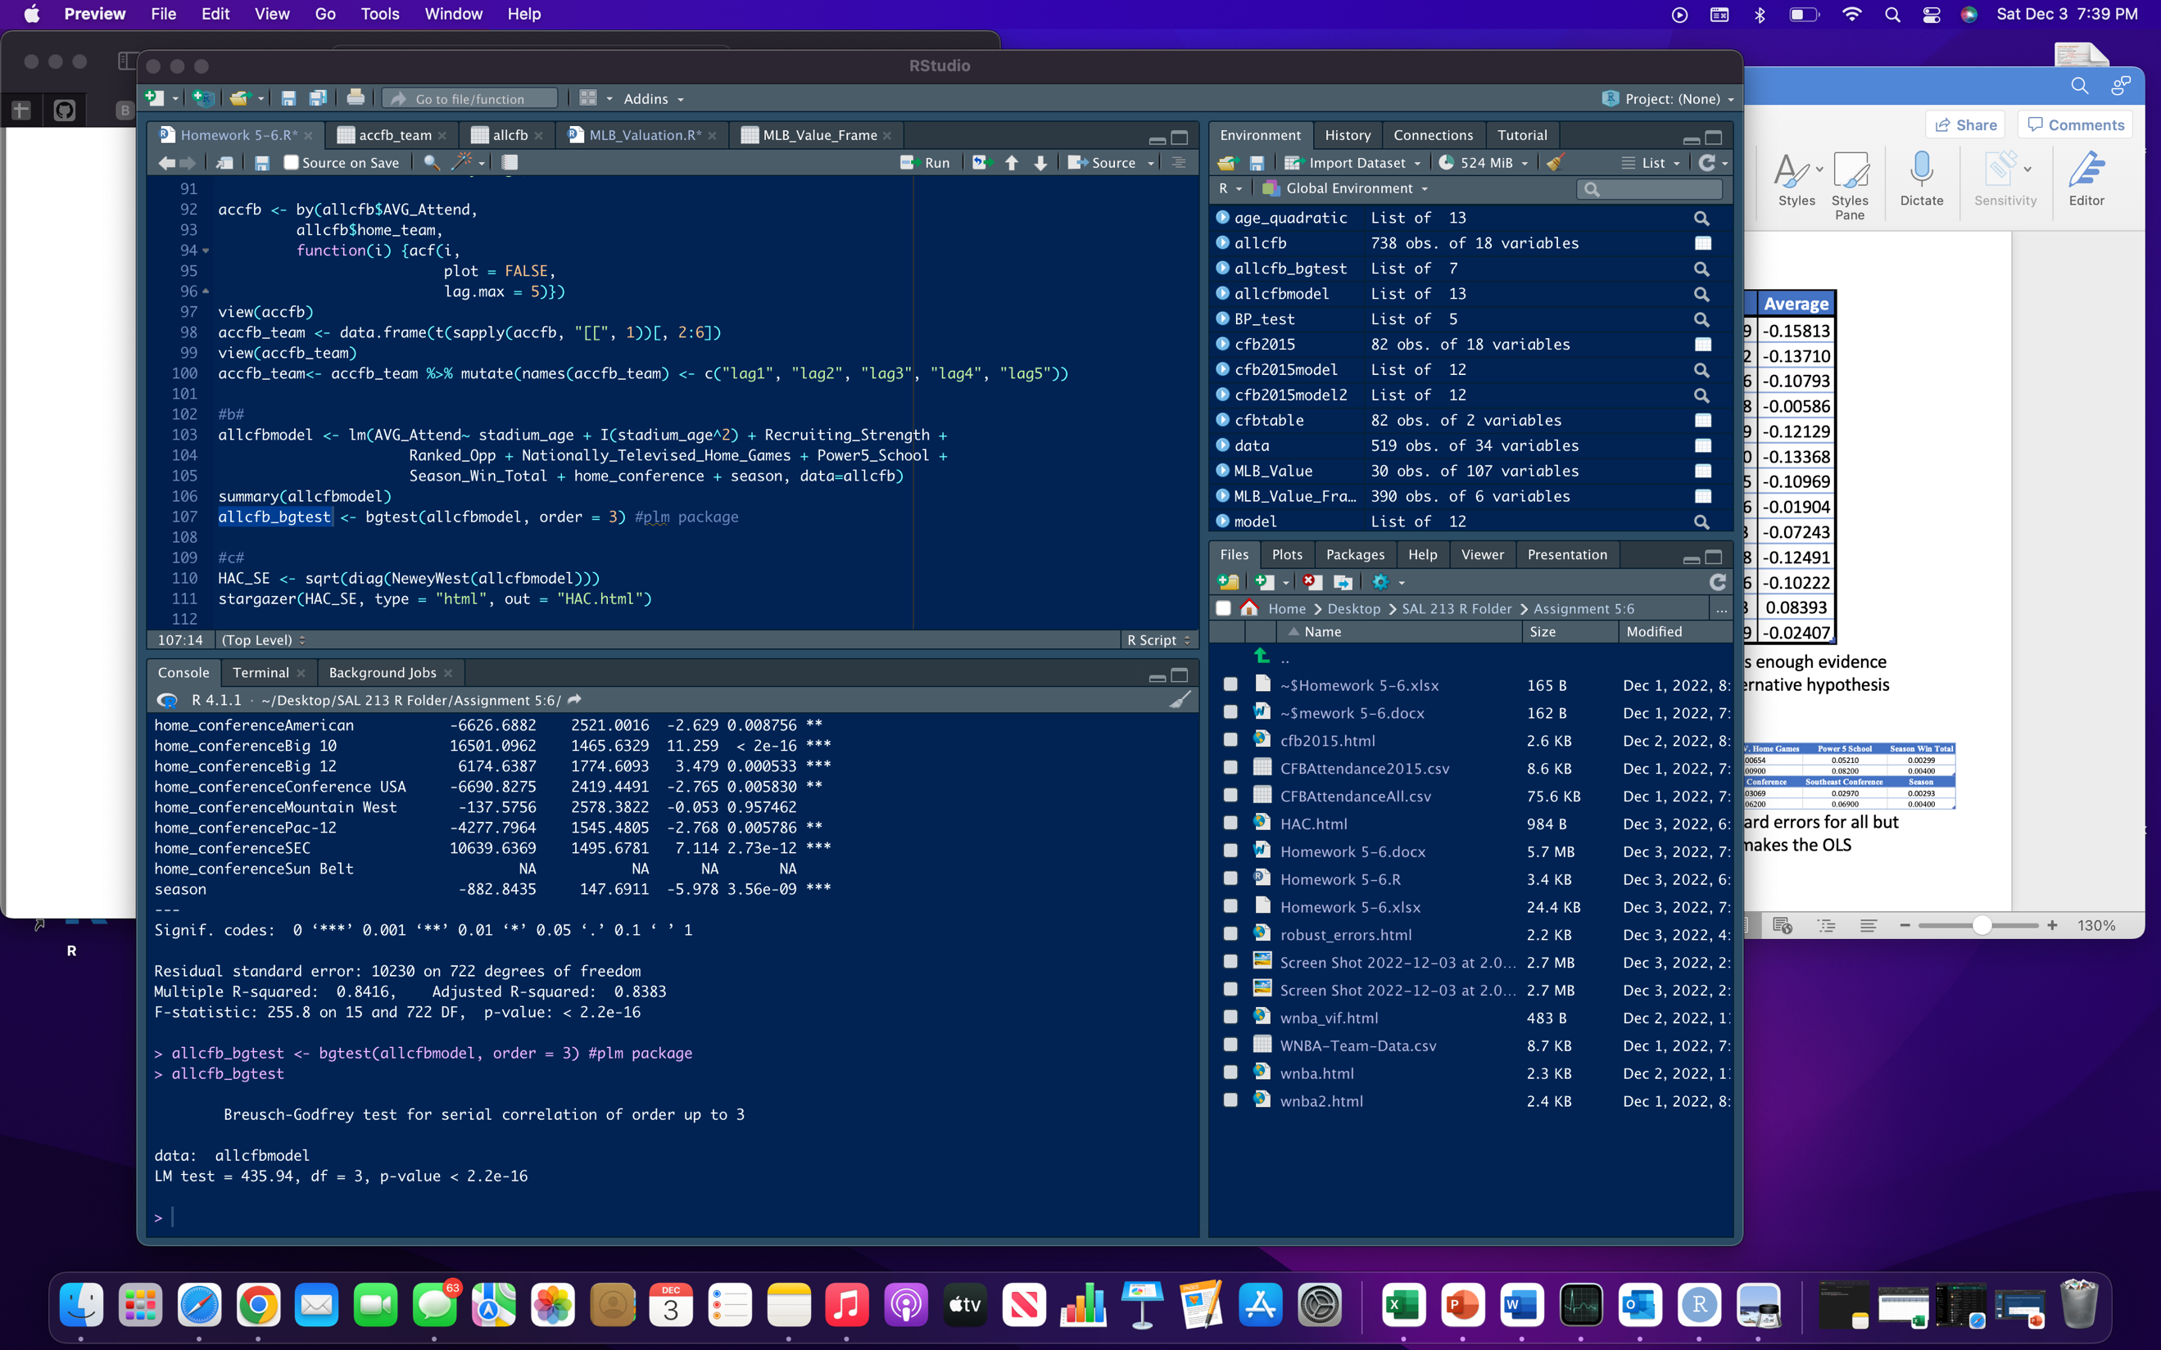 Since the p-value is under the .05 level, there is enough evidence to reject the null hypothesis of no autocorrelation in favor of the alternative hypothesis which is autocorrelation.

c.  In terms of this model, autocorrelation created smaller standard errors for all but one variable which then leave hypothesis tests as unreliable. It also makes the OLS estimates inefficient, making them BLU instead of BLUE.

d. 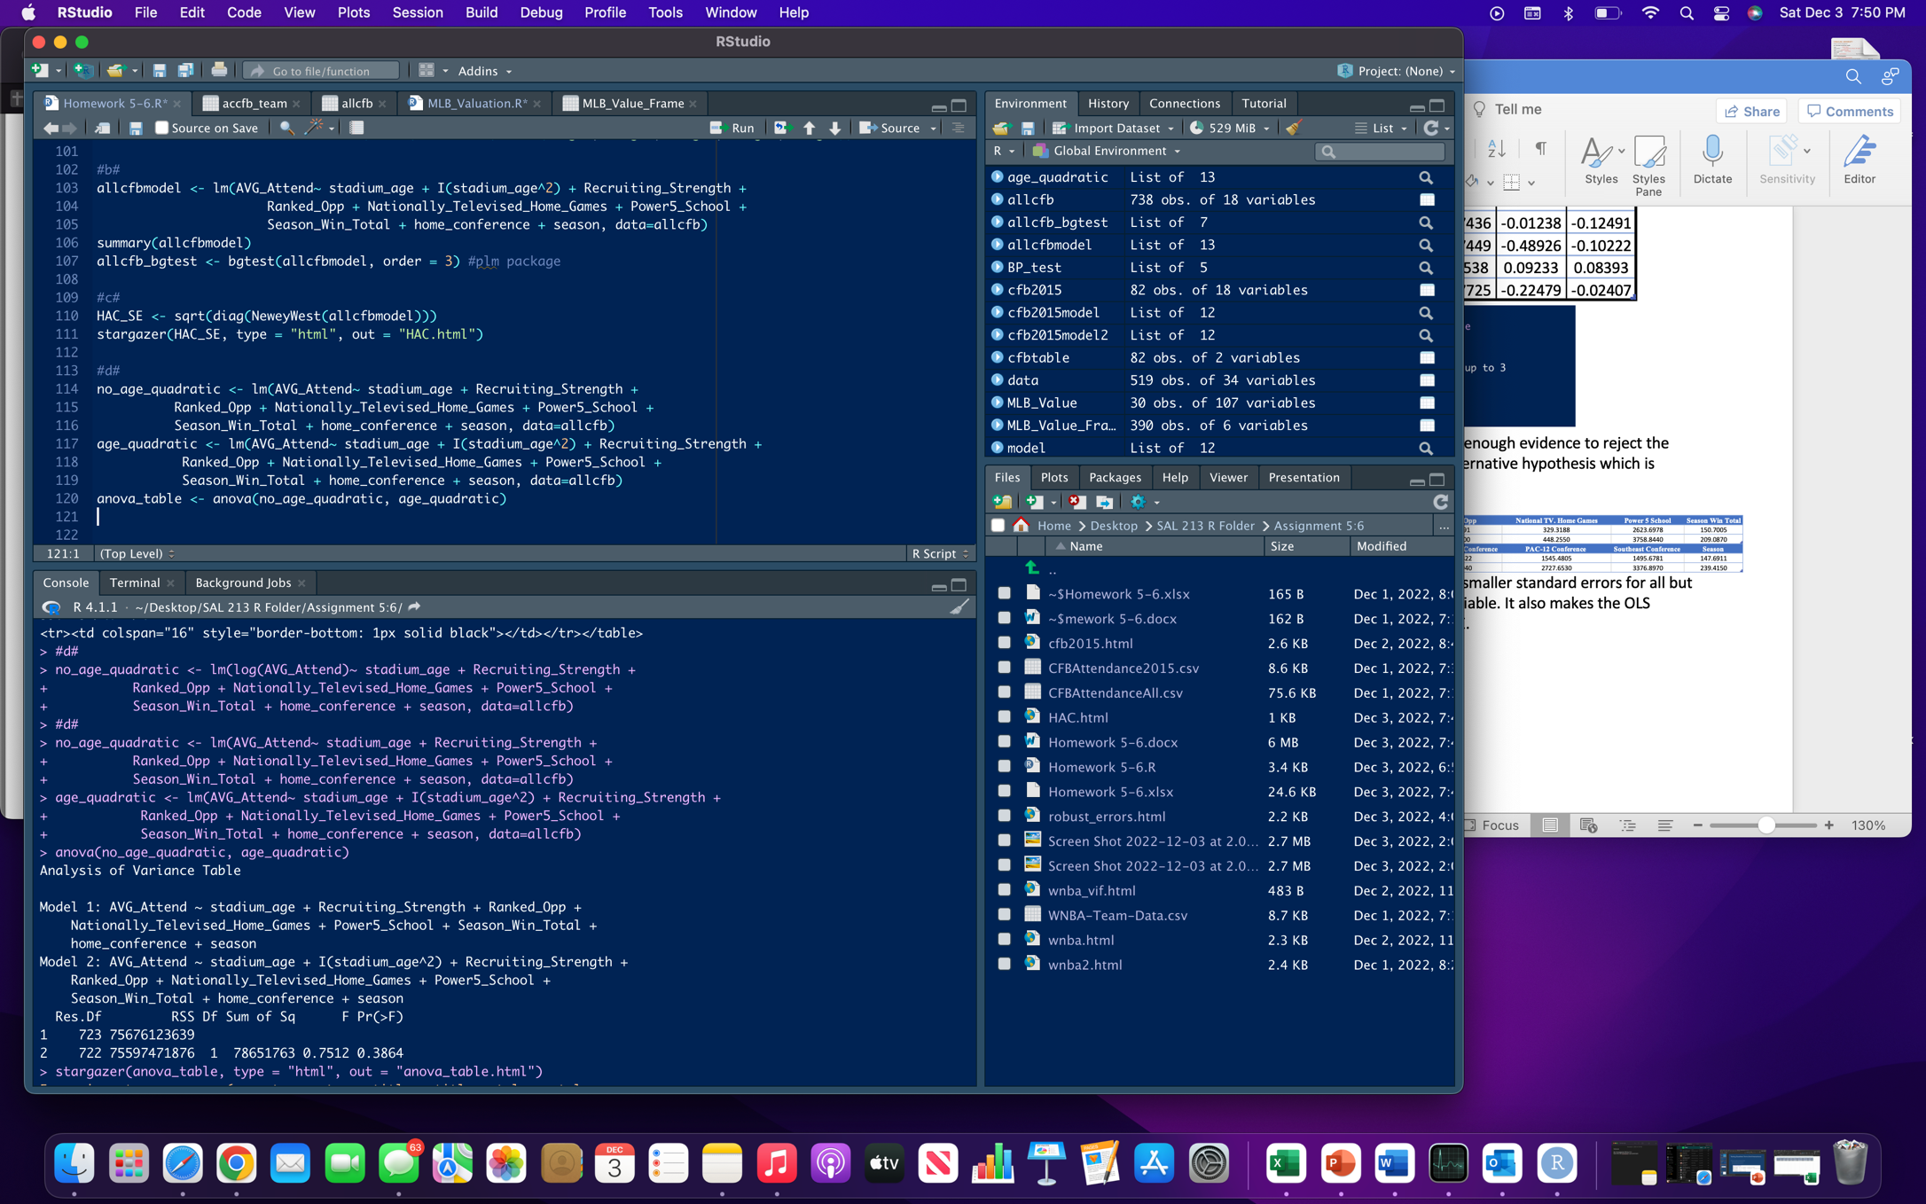 The p-value of $λ$ is 0.983 (calculated in R and Excel) which means at the .05 level, there is not enough evidence that the quadratic model is superior to the linear model. Therefore, it should be kept.

e. The p-value of $λ$ for the conference variable is 0.709 (calculated in R and Excel) which at the .05 level means there is not enough evidence that the having the conference variable is better than excluding the conference interval. The p-value of $λ$ for the season variable is 0.88483755 (calculated in R and Excel) which at the .05 level means there is not enough evidence that the having the season variable is better than excluding the season variable. Therefore, both variables should be kept in the model.